Controlled Access and Livestock Fencing (CALF) Initiative Application

Project Name: Date:

Project Lead Contact (name, telephone, address, email):

FWS Biologist (name, telephone, address, email):

Landowner/Cooperator(s) (name, telephone, address, email):

Location of Project (County & Lat/Long Coordinates):

Description and Purpose of Project (why should this project be funded, in < 300 words?)

How wide would the buffer be on average?

Does the landowner wish to maintain the riparian zone through mowing or flash grazing, or will they establish trees, native plants (plants.usda.gov) or allow the site to go fallow? Describe.

Does the applicant have a pending or approved EQIP contract for any other grazing related practices (e.g., rotational grazing, alt. water source, nutrient management plan, etc)?

Yes/No (highlight one) and list the practices applied for or approved.

Is the landowner willing to allow a “field day” at their property or be part of a “success story” to educate other landowners and conservation professionals?

Yes/No (highlight one)

Insert a representative photo of the current site conditions?

ON A SEPARATE PAGE, INSERT AN AERIAL PHOTO OR TOPO MAP OF THE PROPOSED PROJECT AREA THAT OUTLINES THE LOCATION OF THE PROPOSED FENCING, STREAM CROSSINGS, PIPELINE, WATER TROUGHS, TREE PLANTINGS, ETC. See example below:

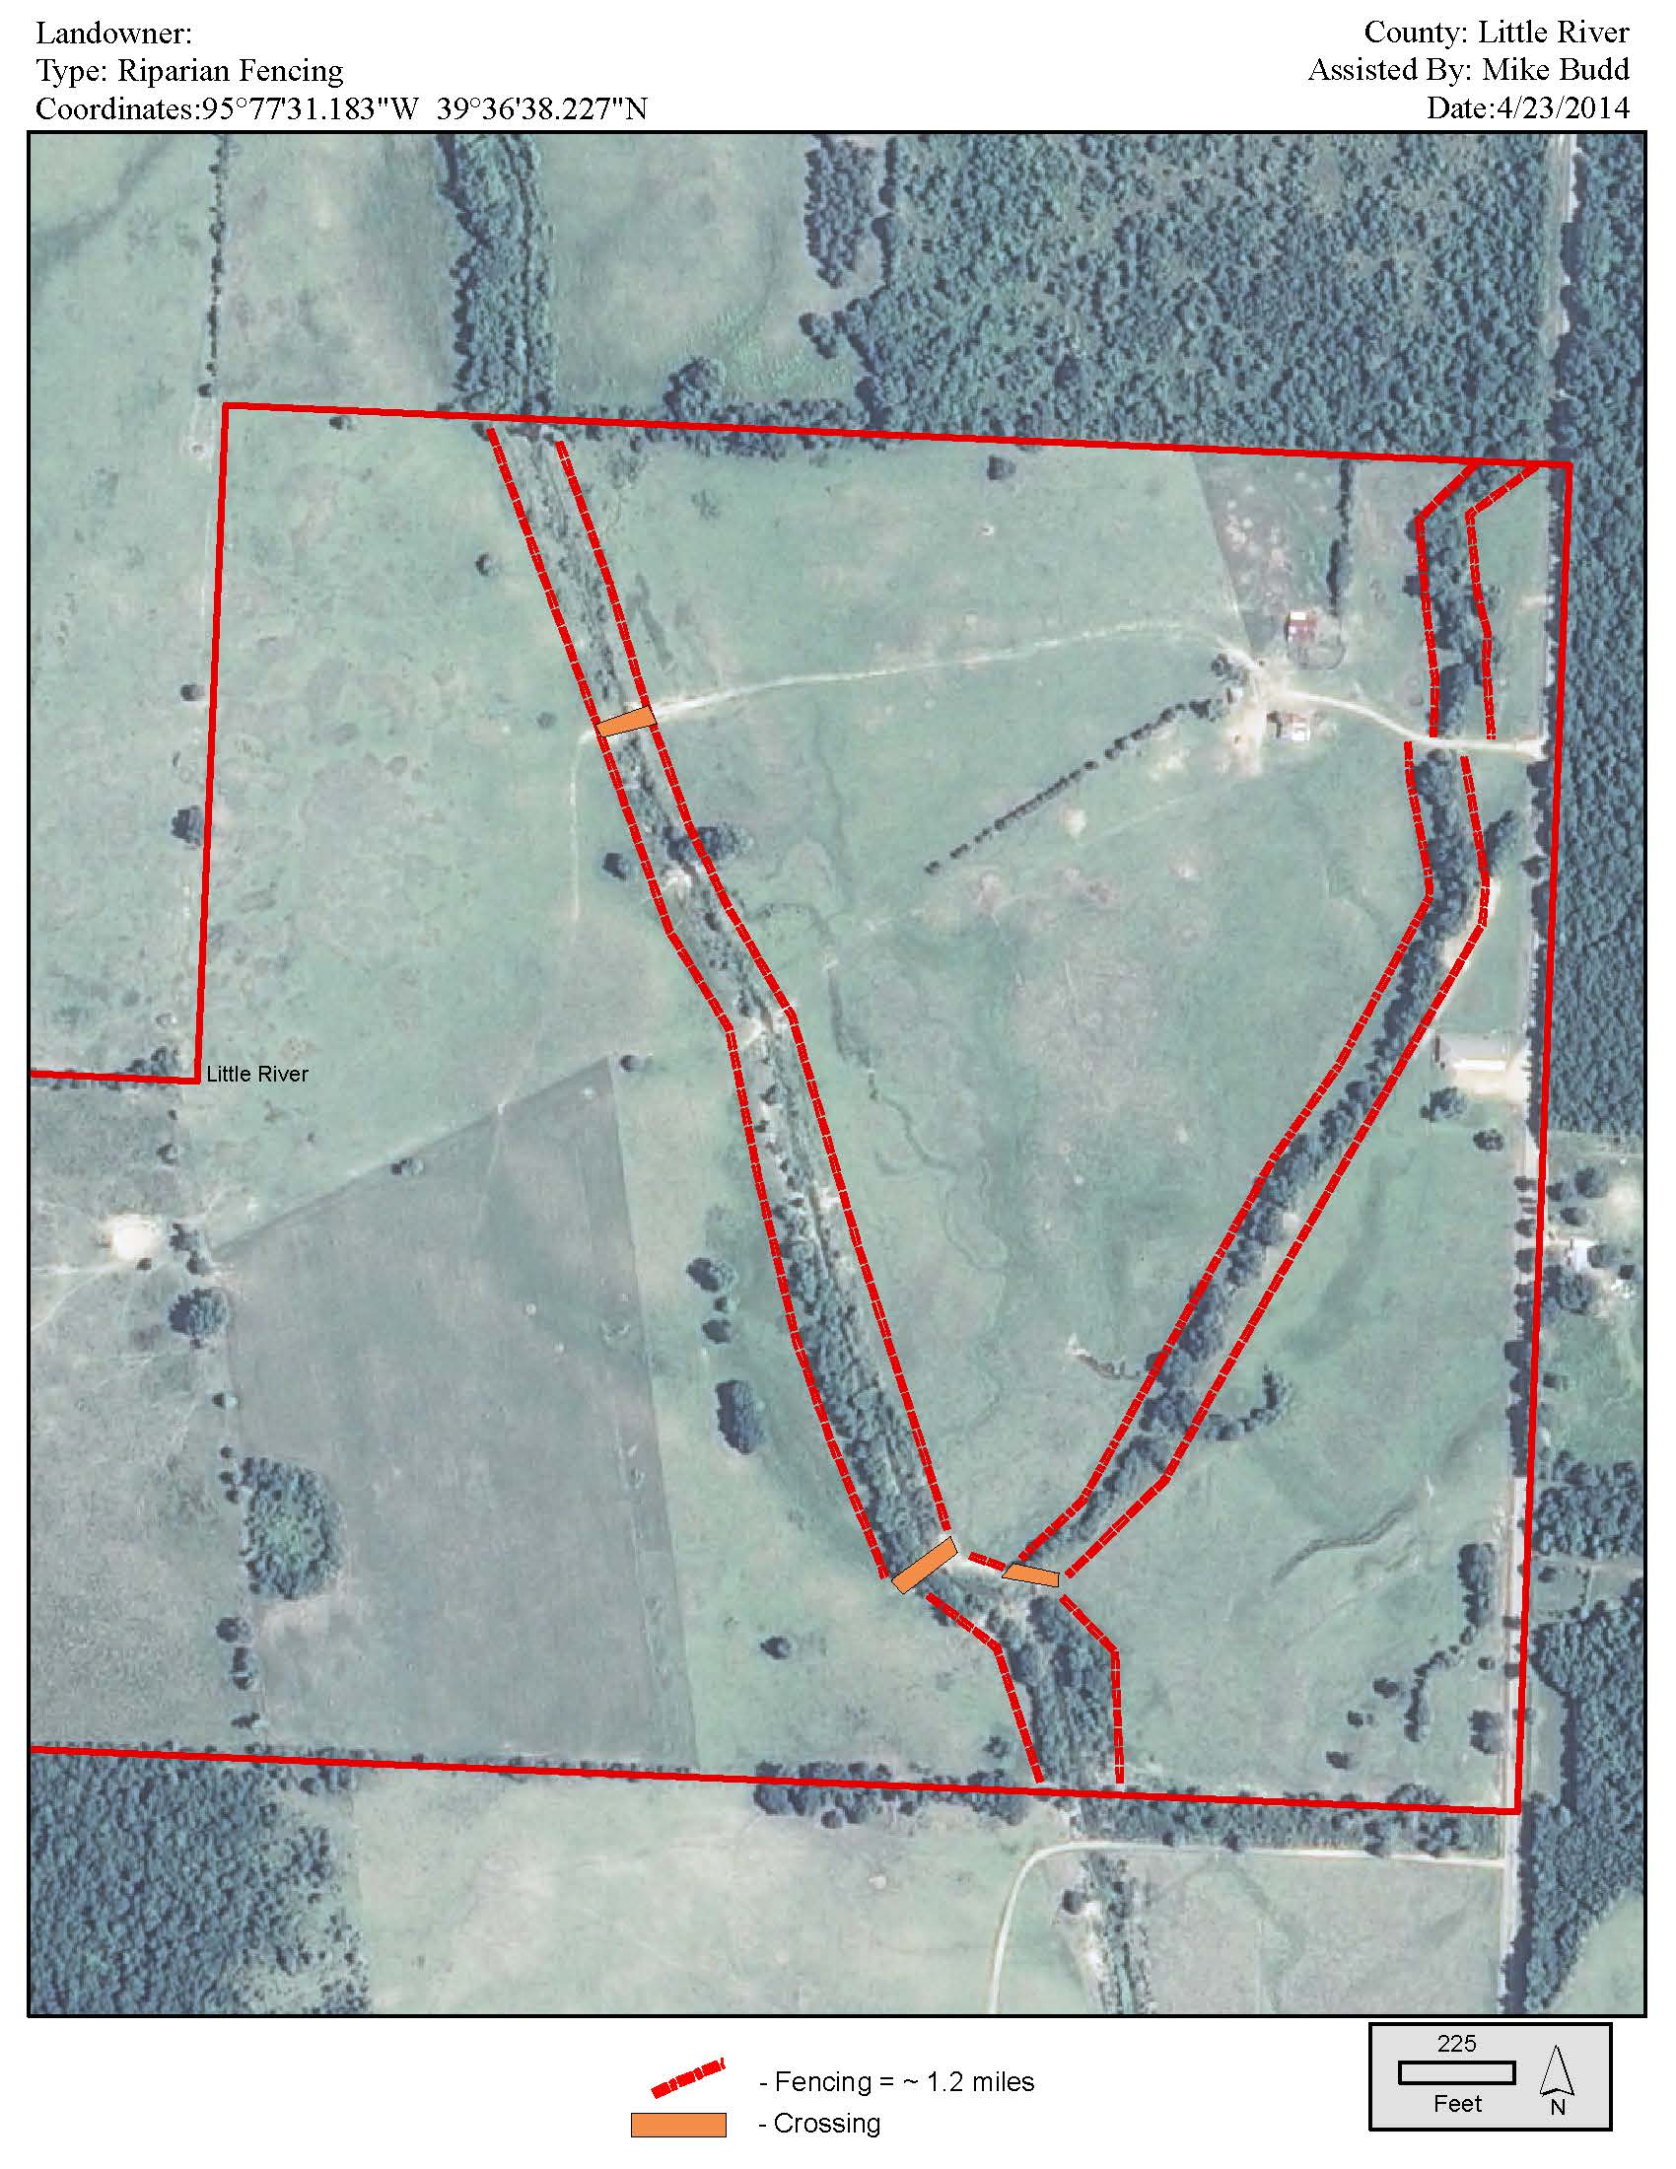
EXAMPLE

MATERIALS REQUIRED (add other items as needed):

Estimated linear feet of fence:
What type of fence (electric, 5-strand barbed wire, high tensile, etc):
Preferred t-post spacing: 10 or 12 ft
Type of troughs:
Number of troughs:
Linear feet of pipeline:
Number of tree seedlings (native species only):
Number and size of solar panels:
Heavy Use Area Protection pads:
Cu.Yds of Gravel/crushed rock:
Other (list):

COST ESTIMATES (consider using the efotg cost data):

Total Overall Project Cost:
Total Funds Requested from AACD:

PARTNERS | Landowner¹  ^{In-Kind Match} | FUNDING REQUESTED | Other Partner  (list, e.g. Stream Team) | Other Partner  (list) | Totals
Equipment Rental | $ | $ | $ | $
  $
  $
  $
  $
  $
  $
Supplies/Materials | $ | $ | $ | $
  $
  $
  $
  $
  $
  $
Labor | $ | $nnnnnnnnnnn | $ | $ | $
Contractor Costs² | $ | $ | $ | $ | $
Totals | $ | $ | $ | $
  $
  $
  $
  $
  $

¹For in-kind contributions from the landowner pertaining to time spent constructing the fence, installing pipeline, etc; use the following rates for labor:

  - Barbed or Smooth-wire Fencing: $0.63/linear foot of fencing to be installed
  - Electric Fencing: $0.11/linear foot of fencing to be installed
  - Pipeline Installation: $1.13/foot
  - Gravel spreading: $18.00/hour and 4 hours/heavy use area
  - Trough installation: $75.00/trough
  - Seedling planting: $40.00/acre
  - Site prep with bush-hog: $30/hour

If other rates or categories are used, provide justification such as NRCS economic data (http://efotg.sc.egov.usda.gov/treemenuFS.aspx then “Cost Data, Payment Schedule Data”) for the practice.

² If hiring a contractor to do the work, just provide the estimated overall costs for hiring a contractor. Do not worry about splitting out the materials, labor, etc.

Other Cooperators (e.g., NRCS, State Agency, etc.):

Indicate How Restoration Work Will Be Performed (check one or more)

REIMBURSEMENT TO LANDOWNER

OUTSIDE CONTRACT

__ OTHER (e.g., agency/NGO) - Specify

Return this completed application to:

Debbie Moreland, debbiepinreal@aol.com

and

Joe Krystofik, joe_krystofik@fws.gov

(A copy will be provided to USFWS Private Lands Coordinator/Conway, Arkansas)
****************************************************************

To be completed by Project Review Team:

Project Number: ________ __
Project Name: ________

Total funding applied for: $_ _ ________
Funding approved: $___ _______
Date: ________ _______________
Comments: ________ ______________ _ ________ _______________ _______ _ _______________ _____ ___ _______________ ________ __ _____________ ________ _______________ __ ______ _______________ ________ _ ______________ ________ _______________ ________ _______________ ________ _______________

